KINDLY SPONSORED BY ‘THE NORTHERN SNOOKER CENTRE’

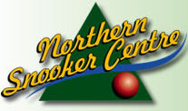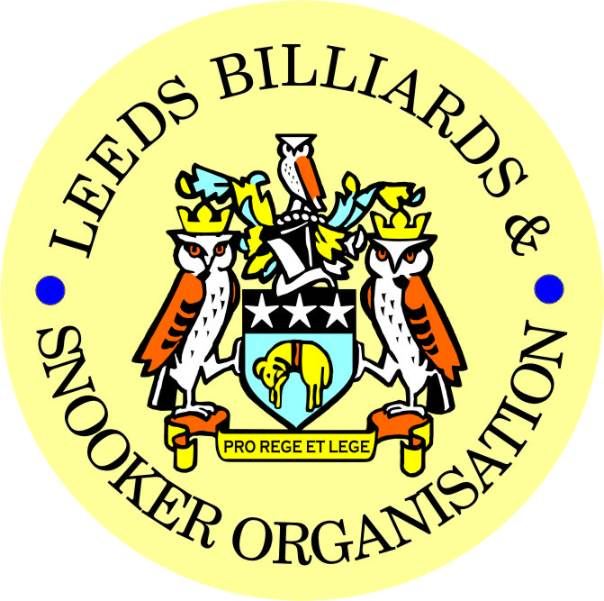

**2014-2015 PRIZE PRESENTATION EVENING**
**WEDNESDAY 8th JULY 2015**
** BRAMLEY BAND CLUB**

** LEEDS CITY CHAMPIONSHIPS - JUNIORS **
U.16’s & U.18’s – SNOOKER – (Scratch)

UNDER 16’s SNOOKER:
WINNER: CALLUM BERESFORD | RUNNER-UP: JAKE BELL
SEMI-FINAL: SAMUEL LEE-STEVENS | SEMI-FINAL: KAIF SHAZAD
UNDER 18’s SNOOKER:
“The Keith Weston Memorial Trophy”- Sponsored by ADT Flexibles (UK) Ltd.
WINNER: LEWIS GILLEN | RUNNER-UP: KIAN COLLINS
SEMI-FINAL: OLIVER MULCAHY | SEMI-FINAL: ROBERT THOMPSON
JUNIOR HIGH BREAK:
“The Paul Hunter Memorial Trophy” – LEWIS GILLEN (57)

**2014-15 YBSA – YORKSHIRE INTER-DISTRICT LEAGUES**

BILLIARDS LEAGUE  CHAMPIONS  LEEDS  For the 9th consecutive year  A NEW RECORD!  Squad Players | SNOOKER LEAGUE  DIVISION 1  LEEDS No.1  Squad Players | SNOOKER LEAGUE  DIVISION 2  LEEDS No.2  Squad Players
Johnathan Bagley (Captain) | Anthony Massey (Captain) | Stephen Broadhead (Cap)
Bob Patterson | Ian O’Brien | Chris Hart
Dave Barker | Mark Ball | Tommy Doherty
 | Lewis Gillen | Warren Rushman
 | Mick Jensen | Ryan Walton

SNOOKER - “Veterans Trophy” | REFEREES:  Officiated in 2014-15 LBSO Competitions:
WINNER: Howard Brazil | KENNETH SYMONS
RUNNER-UP: Peter Brier | SIMON COYNE
 | ALEX CRUM
PLATE WINNER: Brian Chambers | MICHAEL DAVENPORT
PLATE RUNNER-UP: Paul Grimes | IAN WALKER
 | PETER WALKER
 | BOB PATTERSON

Break for Entertainment – Main Presentation to follow afterwards:

** LEEDS CITY CHAMPIONSHIPS **
(Scratch)
BILLIARDS:
WINNER: TBC | RUNNER-UP: TBC
INDIVIDUAL SNOOKER:
WINNER: JOHNATHAN BAGLEY | RUNNER-UP: JOHN GILLEN
SEMI-FINAL: RICHARD BINNS | SEMI-FINAL: TOMMY DOHERTY
PAIRS SNOOKER:
WINNERS: J.BAGLEY / S. LAM | RUNNERS-UP: M.BALL / M. JENSEN
SEMI-FINAL: B. GOULDING / C. HART | SEMI-FINAL: L.GILLEN / J.GILLEN
TEAM SNOOKER – “The Jim Fowler’s Trophy”:
WINNERS: CROSSGATES REC. HALL | RUNNERS-UP: HAREHILLS LIBERALS

LEN LEE INVITATION SNOOKER – (Scratch):  “THE LEN LEE TROPHY” | WINNER: JOHNATHAN BAGLEY  RUNNER-UP: DANIEL WOMERSLEY

** LBSO - BILLIARDS & SNOOKER LEAGUES **

Div: | CUP TITLE / WINNERS: | RUNNERS-UP:
Billiards | The Yorkshire Evening News Cup:  SWARCLIFFE WMC | MAIN LINE SOCIAL
Div A | The Yorkshire Evening News Shield:  SWARCLIFFE WMC ‘A’ | NORTHERN S.C. ‘B’
Div B | The Clan Tartan Trophy:  MIDDLETON CONS ‘A’ | QUEENSWOOD SOCIAL
Div C | The John Dunning Trophy:  YORKSHIRE RIDER | BEESTON HILL SOCIAL ‘B’
Div D | The J. H. Lunn Cup:  MEANWOOD WMC | BEECHWOOD WMC ‘A’
Div E | The Peter Nelson Trophy:  GILDERSOME CONS ‘B’ | CORPUS CHRISTI ‘A’
Div F | The Peter Hawkyard Memorial Trophy:  147 SPORTS BAR | NORTHERN S.C. ‘D’
Div G | The Joe McDonnell Trophy:  HAREHILLS LABOUR ‘B’ | ROWLAND ROAD ‘C’
Div H | The Keith Darley Trophy:  BEECHWOOD WMC ‘B’ | THE NEW MIDDLETON CLUB

“CHAMPION of CHAMPIONS”  “The Jim Williamson Memorial Trophy” | WINNERS: MIDDLETON CONS ‘A’  (DIVISION B WINNERS)
SNOOKER – Individual Handicap.
The “GEORGE SYKES CUP”
WINNER: PAUL BURRILL  (BRAMLEY VILLAGERS) | RUNNER-UP: LIAM NICHOLSON  (BEESTON HILL SOCIAL)
SEMI-FINAL: OLIVER MULCAHY  (NORTHERN S.C.) | SEMI FINAL: PAUL AVEYARD  (NORTHERN S.C.)

SNOOKER – Pairs Handicap.
The “LEN LEE CUP”
WINNERS: J. PEARSON & L. BROOKES  (GARFORTH WMC) | RUNNERS-UP: D. WAITE & G. BINNS  (HUNSLET CARR S & S)
SEMI-FINAL: A. TAFFINDER & D. GRIMES  (ACKROYD ST. WMC) | SEMI-FINAL: S. OUGH & J. CROSSTHWAITE  (BELLE ISLE WMC)

SNOOKER - 3 MAN TEAM KNOCK OUT – (Handicap).
The “Leeds & District Billiards League Snooker Cup”
WINNERS: BRAMLEY BAND CLUB | RUNNERS-UP: THE NEW MIDDLETON CLUB
SEMI-FINAL: MIDDLETON CONS | SEMI FINAL: BRAMLEY VILLAGERS

BILLIARDS HANDICAP:  “YORKSHIRE EVENING POST SHIELD” | WINNER: TBC  RUNNER-UP: TBC

** STAN BROOKE MEMORIAL COMPETITIONS **
(AGGREGATE SCORES)
INDIVIDUAL SNOOKER – 3 FRAMES:
WINNER: PAUL BURRILL  (BRAMLEY VILLAGERS) | RUNNER-UP: IAN RAYNER  (PEGGY TUB SOCIAL)
SEMI-FINAL: ALAN HARDING  (HAREHILLS WMC) | SEMI FINAL: STUART OUGH  (BELLE ISLE WMC)
PAIRS SNOOKER – 3 FRAMES:
WINNERS:  L. GRIMES & P. GRIMES  (ACKROYD ST. WMC) | RUNNER-UP:  W. HARDY & M. McGUIGAN  (BRAMLEY BAND CLUB)
SEMI-FINAL  G. GRIFFIN & A. BEDFORD  (HOLBECK WMC) | SEMI-FINAL:  T. MASSEY & S. O’BRIEN  (HAREHILLS WMC)
TEAM SNOOKER – 4 FRAMES:
WINNERS: CROSSGATES REC. HALL | RUNNERS-UP: EAST END PARK
SEMI-FINAL: ACKROYD ST. WMC | SEMI-FINAL: BEESTON HILL SOCIAL

The “WINDSOR TROPHY” – 4 Man Team Handicap

WINNERS: ACKROYD ST. WMC | RUNNERS-UP: UP. & LOWER WORTLEY LIBS
SEMI-FINAL: BELLE ISLE WMC | SEMI FINAL: BEECHWOOD WMC

LBSO LEAGUE - HIGHEST BREAKS – BILLIARDS & SNOOKER
Billiards ‘A’ – (-200 to +19) | 159 – Johnathan Bagley (-235) – Swarcliffe WMC
Billiards ‘B’ – (+20 to +200) | 66 – Paul Easton (+90) – Swarcliffe WMC
Snooker – Group 1 (-80 to -20) | 116 – Johnathan Bagley (-53) – Harehills Labour ‘B’
Snooker – Group 2 (-19 to +5) | 101 – Lewis Gillen (-15) – New Wortley Labour
Snooker – Group 3 (+6 to +20) | 61 – Joe Harrison (+9) – Middleton Cons ‘A’
Snooker – Group 4 (+21 to +30) | 56 – Gary Jukes (+24) – Beechwood WMC ‘A’
Snooker – Group 5 (+31 to +80) | 52 – Johnathan Ramsden (+36) – Holbeck WMC ‘A’

CONGRATULATIONS TO
ALL PRIZE WINNERS!

The LBSO would like to thank the Committee and Members of
The Bramley Band Club for staging this year’s Presentation Night.

A.G.M.

MONDAY 13th JULY 2015 – 7-45pm
at
HOLBECK WMC

PRESIDENT – CHRIS WILLIAMSON
CHAIRMAN – RODNEY SIMS
VICE CHAIRMAN – ANDY TAFFINDER
LEAGUE SECRETARY – PAUL GRIMES
COMPETITION SECRETARY – LEE GRIMES
GENERAL SECRETARY / TREASURER – BOB PATTERSON

The LBSO would like to thank the Committee and Members of Holbeck WMC, for allowing us the use of the club for LBSO delegate meetings and the AGM, throughout this season and in the past.

Produced By
Kindly Sponsored by the ‘NORTHERN SNOOKER CENTRE’

